Leakage-Aware Privacy-Practice Classification:

A Comparative Study of Classical and Neural Models under Policy-Disjoint Evaluation
Nafiz Ahmed Nafi Priom Halder
MD. Amirul Islam Sadat Samiha Tasnim Orthi Department of Computer Science and Engineering, BRAC University
nafiz.ahmed.nafi@g.bracu.ac.bd priom.halder@g.bracu.ac.bd amirul.islam.sadat@g.bracu.ac.bd samiha.tasnim.orthi@g.bracu.ac.bd
August 29, 2026

Abstract

Privacy policies govern how personal data is collected, shared, and retained, yet most users never read them in full. We study au-tomatic classifica-tion of annotated privacy-policy spans into eight data-practice categories us-ing the OPP-115 corpus (17,343 labeled spans, 115 policies). TF-IDF is used for the completed classical experiments; a Word2Vec pipeline was implemented but not exe-cuted for a completed down-stream classification experiment. Mod-els span three classical approaches (Ran-dom Forest, Logistic Regression, Naive Bayes) and seven neural architectures (SimpleRNN, GRU, LSTM, their bidi-rectional variants, and a partially fine-tuned BERT Base). Our central con-tribution is a systematic comparison of two evaluation protocols: a con-ventional row-level stratified split and a policy-disjoint split that holds en-tire policies out of training. Be-cause privacy policies reuse boilerplate lan-guage across unrelated documents, the row-level split inflates macro-F1 by 0.0150.123 depending on the model and changes the apparent ranking. Un-der the honest, policy-disjoint evalua-tion, BERT Base achieves the highest macro-F1 (0.706), narrowly ahead of Naive Bayes (0.701), while showing the smallest evaluation-protocol gap of any
model trained. The results suggest that document-grouped evaluation should be stan-dard practice for any text classifi-cation task built on corpora with reused or template-based language.
- Introduction
Privacy policies are the main legal instrument through which organizations disclose how they collect, use, share, and re-tain personal data. In practice they are long, formulaically writ-ten, and inconsistently structured, and sur-veys of user be-havior repeatedly find that al-most nobody reads one in full before consent-ing (McDonald & Cranor, 2008). Automati-cally mapping policy text onto a standardized taxonomy of data practices would let down-stream tools summarize a pol-icy at a glance, flag GDPR or CCPA-relevant language, or let researchers compare practices at corpus scale. This is a multi-class text classification problem and not a saturated task: privacy language is technical, class frequencies are heavily skewed, and a single clause often expresses more than one practice at once.
We build our study on the OPP-115 cor-pus (Wilson et al., 2016), 115 real-world web-site privacy policies annotated by legal experts against a fixed schema of data-practice cate-gories. We treat each annotated span as one classification instance labeled with one of eight practice categories.
A less obvious property of this corpus mo-tivates the pa-pers central contribution. Pri-vacy policies reuse legally vetted boilerplate

language across unrelated organizations tem-plate clauses drafted by the same law firm recur verbatim across dozens of policies. A conventional row-level train/test split ignores this structure and can place near-identical boil-erplate on both sides, letting a model score well by recognizing mem-orized phrases rather than by learning what privacy language of a given category actually looks like. This is an instance of the broader evaluation-leakage problem documented in NLP by Gorman & Bedrick (2019) and Lewis et al. (2021).
Research questions: RQ1. How does a conventional row-level split change measured performance relative to a policy-disjoint split for the same model? RQ2. How does this evaluation-protocol gap vary across classi-cal, recurrent, and transformer architectures? RQ3. Which model achieves the best macro-F1 on entirely unseen policies?
Contributions: (1) A leakage-aware eval-uation framework contrasting row-level and policy-disjoint splits across ten mod-els span-ning four architecture families. (2) An empir-ical find-ing that the evaluation-protocol gap varies substantially across model families. (3) A full implementation of the required clas-sical and neural suite, with implementation gaps (Section 4.4) documented openly rather than omitted. Context-aware mod-eling, imbalance-aware training, and external validation are left for future work (Section 5).

- Related Work
Privacy-policy NLP. The OPP-115 corpus (Wilson et al., 2016) is the standard manually annotated benchmark for data-practice clas-sification in privacy policies. Harkous et al. (2018) present Polisis, a deep-learning pipeline that classifies policy segments and supports downstream question answering, estab-lishing that neural models can substantially outper-form earlier rule-based approaches. Our work differs in focus: rather than proposing a new architecture, we study how the evaluation pro-tocol specifically, whether the split respects document-level structure changes which archi-tecture appears to win.
Classification models. TF-IDF paired with classical classi-fiers remains a strong, fast base-line (Pedregosa et al., 2011). Word embed-
dings such as word2vec (Mikolov et al., 2013) and GloVe (Pennington et al., 2014) enable generalization across related terms. Recurrent architectures LSTM (Hochreiter & Schmidhu-ber, 1997), GRU (Cho et al., 2014), and their bidi-rectional variants (Schuster & Paliwal, 1997) model sequen-tial dependencies that bag-of-words representations discard. BERT (Devlin et al., 2019) adds contextual represen-tations from large external corpora before task-specific fine-tuning.
Evaluation leakage and class imbalance. Gorman & Bedrick (2019) show that re-splitting standard NLP bench-marks changes both absolute scores and relative rankings. Lewis et al. (2021) document a related failure in question answering where train/test over-lap inflates reported accuracy. Our work ap-plies the same principle splits must respect data grouping structure to a domain where that structure is un-usually explicit. Johnson & Khoshgoftaar (2019) survey class-imbalance mitigations; we adopt macro-F1 as the pri-mary metric and include class-weighted con-figurations throughout.

- Methodology
  - Dataset and Exploratory Data Analysis
Corpus. We use the OPP-115 corpus (Wil-son et al., 2016): 115 website privacy policies, each annotated by three anno-tators against a fixed schema, later merged at a 0.75 overlap-similarity threshold that reproduces the cor-puss own 92/23 policy train/test split. We take the longest populated selected span as the classification input and attach its surrounding clause as optional context. Two of the ten original categories, Other and Do Not Track, are dropped, leaving eight: First Party Col-lection/Use, Third Party Sharing/Collection, User Choice/Control, Data Security, User Ac-cess, Edit and Dele-tion, International and Specific Audiences, Policy Change, and Data Retention.
Scale. The working dataset contains 17,343 labeled spans from 3,204 distinct underlying clauses and 115 policies. Of the 17,343 rows, 4,959 are repeated (span, category) pairs, an early signal of the boilerplate reuse that moti-vates our evalua-tion design. Annotated spans are short (mean 137 characters; median 15

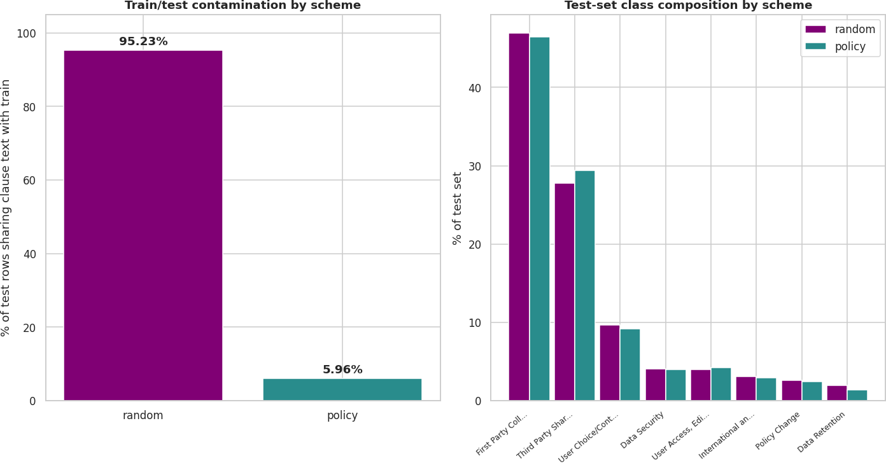

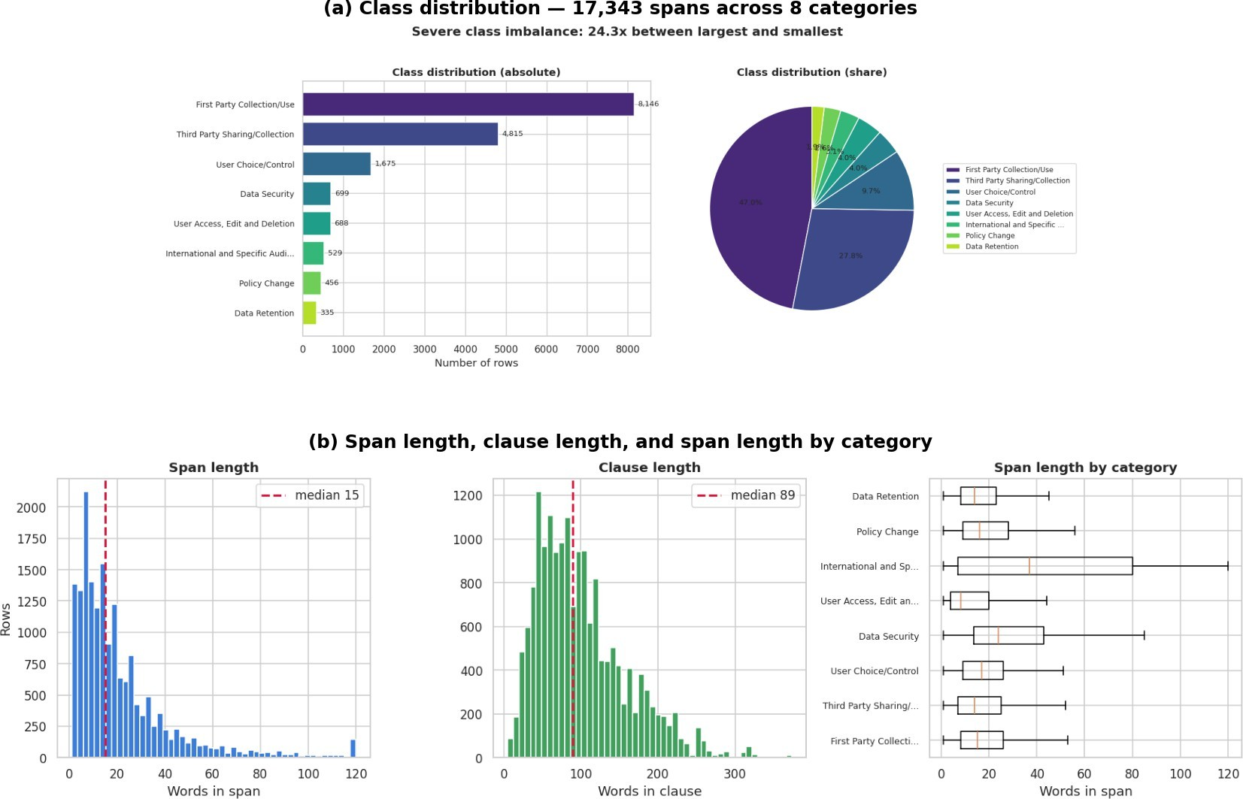
Figure 1: (a) Category distribution over 17,343 spans (24.3× largest/smallest ratio). (b) Span length, clause length, and span length by category; dashed lines mark the median.

words); surrounding clauses are longer (me-dian 89 words).
Class distribution and span lengths. Figure 1 shows the class distribution and span/clause-length distributions. First Party Collec-tion/Use and Third Party Sharing/Collection to- gether account for 74.7% of all rows, while Data Retention accounts for only 1.9% a
24.3× imbalance. This is why accuracy is never reported as a standalone metric any-where in this paper; every evaluation cen-ters macro-F1 and reports full per-class break-downs. Span lengths are mostly short, with a long right tail (maximum 1,873 characters); this motivates the 48-token sequence-length cap used for the recurrent models.
Multi-practice clauses. 1,119 of 3,204 dis-tinct clauses (34.9%) carry more than one category simultaneously a sentence such as we collect your email address and may share it with advertising partners unless you opt out simul-taneously expresses First Party Col-lection/Use, Third Party Sharing/Collection, and User Choice/Control. This is why the clause is never used as the sole classification input; a clause-level single-label formulation would force one label onto text that legiti-mately expresses several practices.
Boilerplate reuse. Under the conventional row-level ran-dom split, 113 of 115 policies ap-pear on both sides and 95.2% of test rows share clause text with some training row. Under the policy-disjoint split, that figure drops to 6.0% real-world boilerplate reuse across un-related organizations rather than an artifact
Figure 2: Left: percentage of test rows sharing clause text with training, by split scheme. Right: test-set class composition under each scheme. The two schemes differ not only in overlap but also in which policies compose the test set, so the macro-F1 gap between them is an evaluation-protocol gap, not a pure causal measure of leakage.

of the split. Figure 2 visualizes this contrast. The 95.2%-versus-6.0% difference is the con-crete motivation for the dual-scheme evalua-tion in Section 3.5.
  - Preprocessing
the row-level random scheme used as the leaky comparison condition in this paper, 113 of 115 policies appear on both sides of the split and 95.2% of test rows share clause text with some training row. This gap 6.0% irreducible real-world reuse versus 95.2% construction-induced leakage is the concrete motivation for the dual-scheme evaluation protocol in Section 3.5.
Word cloud. Figure 3 visualizes the most frequent terms across all annotated spans af-ter standard stop-word removal, dominated by data-practice vocabulary (information, per-sonal, data, use, third party, may) that is broadly shared across categories – itself a pre-view of the category-overlap difficulty dis-cussed in Section 4.
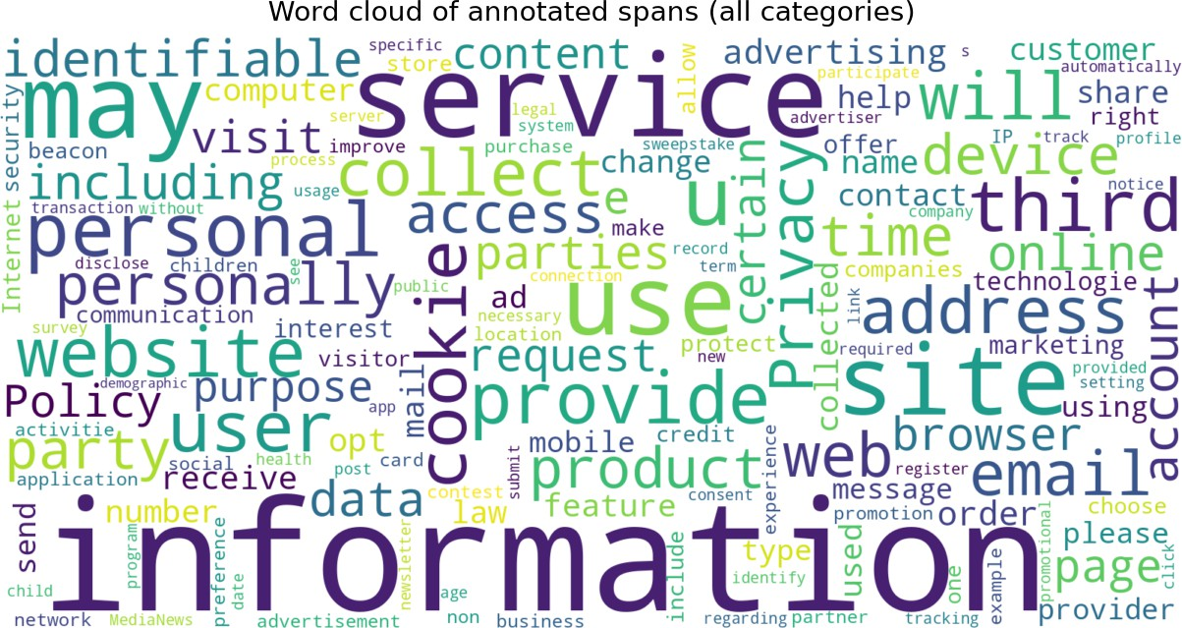

Figure 3: Word cloud over all annotated spans (En-glish stopwords removed).

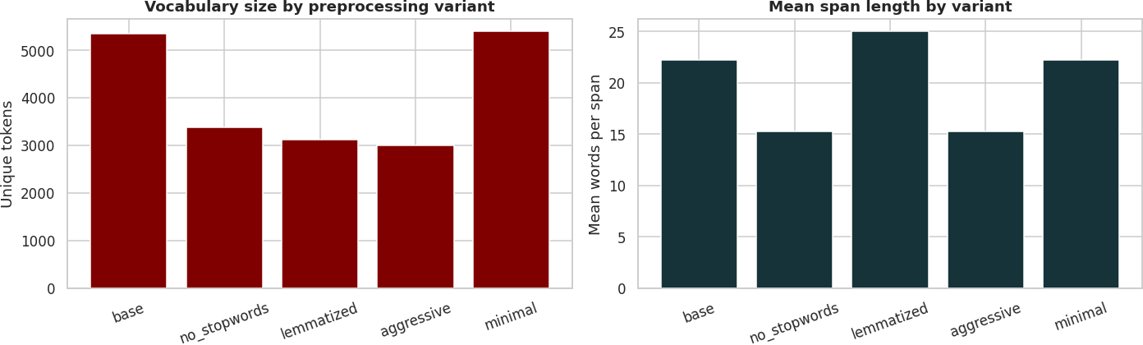
Table 1: Preprocessing variants and their intended usage.

Variant Processing Intended for

base HTML re-moval, place-holders, lower-case
no_stopwords base + NLTK
stopword re-moval
lemmatized base + Word-
Net lemmatiza-tion
aggressive stopwords + lemmatization
minimal HTML re-moval, lower-case only
Classical, RNN (actual)

Alt. TF-IDF

RNN (de-
signed)

Sparse configs BERT Base

Figure :4 Vocabulary size and mean span length for each preprocessing variant, measured on a 3,000-span sample. Stopword removal and lemmatiza-tion each reduce vocabulary by roughly a third rel-ative to base.

A skip-gram Word2Vec pipeline was imple-mented using 100-dimensional embeddings, a context window of 5, and minimum token count of 2 (Mikolov et al., 2013), via gen-sim (R ehurek & Sojka, 2010). However, the Word2Vec pipeline was not executed for a com-pleted downstream classification experiment,

We define five preprocessing variants, each matched to a differ-ent downstream represen-tation. Table 1 summarises them. Ev-ery variant first strips HTML markup and re-places URLs and email addresses with place-holder tokens ([URL], [EMAIL]). In the exe-cuted pipeline, the base variant was applied to both the classical and recurrent models; minimal was applied to BERT Base. The designed-but-unexecuted match between lem-matized and the recurrent models is reported as a limita-tion in Section 5.
Figure 6 shows vocabulary size and mean span length for each variant on a 3,000-span sample. Stopword removal and lemmatization each reduce vocabulary size by roughly a third relative to base; combining both (aggressive) gives the smallest vocabulary. lemmatized has a higher mean word count than base despite its smaller vocabulary, most likely because the lemmatizer splits some contracted forms that the base tokenizer keeps intact.
  - Word Representations
TF-IDF(fully evaluated): 5,000-term vocabu-lary, unigrams and bigrams, minimum docu-ment frequency 5, maximum doc-ument fre-quency 0.8, sublinear term-frequency scaling (Pe-dregosa et al., 2011). The vectorizer is refit independently on the training portion of each split scheme to prevent vocabulary leak-age.
Word2Vec(implemented but not evaluated):
so no Word2Vec classification results are re-ported.
GloVe(Pennington et al., 2014): not imple-mented in the executed notebook.
  - Model Architectures, Hyperparameter Grids
Table 2 summarises all ten models, their repre-sentations, and the configurations tested. For every model and split scheme, model selection uses validation macro-F1 and only the win-ning configuration is scored on the held-out test set, so the number of configurations tried never inflates the reported test score.
All six recurrent models share the same design: an em-bedding layer initialized from scratch, a recurrent or bidirec-tional recurrent layer, dropout regularization, and a dense soft-max head. Input sequences are word-index-encoded from a training-only vocabulary and padded or truncated to 48 tokens. Sequence lengths are not tracked separately; the recur-rent layer reads through trailing padding posi-tions rather than stop-ping at the actual span end (lack of length-aware packing is noted un-der Limitations). Models are implemented in PyTorch (Paszke et al., 2019); final experi-ments ran in a CUDA-enabled Python 3.13 en-vironment. BERT Base is fine-tuned via the HuggingFace Transformers library (Wolf et al., 2020) with the token embeddings and first 10 of 12 encoder layers frozen, and input trun-cated to 64 tokens.

Table 2: Model architectures and hyperparameter configurations (3 configs per model × 2 schemes = 60
tuning runs total).
Model | Architecture / repr. | Configurations tested
Random Forest | TF-IDF | 200 trees/unlim.
 |  | depth; 400/depth 60; 300/depth 30, class-weighted
Logistic Reg. | TF-IDF | C=1.0 (1k | iter);
 |  | C=5.0 (2k | iter);
C=1.0, class-weighted
Naive Bayes TF-IDF α=1.0; 0.3; 0.05
SimpleRNN / Bi | Embed → RNN → dropout → softmax | embed | 64/128;
 |  | hidden | 32/64;
 |  | dropout | 0.3/0.5;
lr 10⁻³/5 × 10⁻⁴; one
class-weighted
GRU / BiGRU | Embed → GRU → dropout → softmax | same grid
LSTM / BiLSTM | Embed → LSTM → dropout → softmax | same grid
BERT Base | Last 2 encoder layers + classifier (13.5% params trainable) | lr ∈ {2 × 10⁻⁵, 3 ×
 |  | 10⁻⁵, 5 × 10⁻⁵}; batch
 |  | ∈ {16, 32}; one class-
 |  | weighted

  - Split Schemes
random: Rows are split 70/15/15 (train/val/test), stratified by category, with no regard for policy origin (12,140/2,601/2,602 rows; 113 of 115 policies appear in both train and test). Re-ported here only as a point of comparison against the honest condition; never used as a standalone generalization estimate.
policy: Policies, not rows, are the unit of assignment, built from the corpuss own 92/23 policy split (76/16/23 policies; 11,344/2,088/3,911 rows). No policys rows ap-pear in more than one split. This is the papers generalization estimate and the scheme used for every model-selection decision outside the explicit leakage comparison in Section 4.2.
- Results
All ten models were trained and evaluated under both split schemes for a combined 60 logged tuning runs (18 classical, 36 recur-rent, 6 BERT Base). All numbers are drawn directly from the executed project notebook (project_440.ipynb).
  - Model Comparison
Table 3 reports test-set performance and Fig-ure 6 visualizes the comparison.
Under the honest, policy-disjoint scheme, BERT Base reaches the best overall macro-F1 (0.706), narrowly ahead of Naive Bayes (0.701) a gap of 0.005 that should be read as a near-tie rather than a decisive win. Logistic Regres-sion comes third (0.692). SimpleRNN is the worst model overall (macro-F1 0.131, barely above a majority-class-only baseline of ≈0.08), and Random Forest is the weakest of the three classical models (0.652).
Under the leaky random scheme the picture looks quite dif-ferent: Logistic Regression ap-pears to lead (0.753) and BERT falls to fourth, behind both Random Forest and Naive Bayes. A concrete instance of the accuracy trap ap-pears within the classical models: Random Forest has the highest accuracy of all ten mod-els under the leaky split (0.780) yet the low-est macro-F1 among the three classical models (0.721), a pattern consistent with the model benefiting disproportionately from the major-ity classs repeated boilerplate phrasing. This is a real risk for a project that selects by ac-curacy on a conven-tional split; note, though, that Random Forest is not the worst general-izer overall under policy-disjoint evaluation it still outperforms six of the seven neural archi-tectures.

Table 3: Test performance at each model’s best validated configuration under both split schemes, ranked by macro-F1. Bold marks the best value in each column within each scheme.

Scheme | Model | Accuracy | Macro-F1 | Weighted-F1
random | Logistic Regression | 0.7740 | 0.7534 | 0.7713
random | Random Forest | 0.7798 | 0.7212 | 0.7739
random | Naive Bayes | 0.7575 | 0.7258 | 0.7547
random | BERT Base | 0.7586 | 0.7208 | 0.7553
random | Bidirectional GRU | 0.7640 | 0.6999 | 0.7611
random | Bidirectional LSTM | 0.7598 | 0.6840 | 0.7568
random | Bidirectional SimpleRNN | 0.7283 | 0.6118 | 0.7222
random | LSTM | 0.6914 | 0.5489 | 0.6826
random | GRU | 0.7110 | 0.5194 | 0.7043
random | SimpleRNN | 0.4823 | 0.1719 | 0.4080
policy | BERT Base | 0.7152 | 0.7060 | 0.7138
policy | Naive Bayes | 0.7026 | 0.7011 | 0.6987
policy | Logistic Regression | 0.6789 | 0.6923 | 0.6770
policy | Random Forest | 0.6771 | 0.6516 | 0.6673
policy | Bidirectional LSTM | 0.6699 | 0.6083 | 0.6663
policy | Bidirectional GRU | 0.6331 | 0.5859 | 0.6344
policy | Bidirectional SimpleRNN | 0.6175 | 0.4891 | 0.6090
policy | GRU | 0.5850 | 0.4755 | 0.5832
policy | LSTM | 0.5794 | 0.4425 | 0.5764
policy | SimpleRNN | 0.3863 | 0.1310 | 0.3357

  - Evaluation-Protocol Gap
Table 4: Per-class P/R/F1 for BERT Base (policy-disjoint; accuracy 0.715, macro-F1 0.706).

Figure shows the macro-F1 gap between the
two schemes. We call this an evaluation-protocol gap rather than a pure measure of leakage because the two schemes also dif-fer in test-set size and policy composition; the 95.2%-versus-6.0% clause-overlap evidence makes leakage the most plausible dominant contributor, but we do not treat every decimal point as causally isolated to leakage alone.
Category | P | R | F1
Policy Change | 0.91 | 0.77 | 0.84
Intl. & Spec. Audiences | 0.86 | 0.88 | 0.87
Data Security | 0.77 | 0.88 | 0.82
First Party Coll./Use | 0.76 | 0.78 | 0.77
Third Party Shar./Coll. | 0.66 | 0.64 | 0.65
User Access/Edit/Del. | 0.69 | 0.57 | 0.62
User Choice/Control | 0.56 | 0.62 | 0.59
Data Retention | 0.86 | 0.35 | 0.49

The gap ranges from +0.015 (BERT Base) to +0.123 (Bidi-rectional SimpleRNN). The

three classical models and BERT Base form a comparatively low-gap cluster (+0.015 to +0.070); the six recurrent architectures, trained from scratch with no external pretrain-ing, show both the largest and the most vari-able gap (+0.041 to +0.123), with Bidirec-tional SimpleRNN, Bidirectional GRU, and unidirectional LSTM each exceeding +0.10. BERT Bases gap of only +0.015 is consis-tent with the hypothesis that pretraining on a large external corpus reduces reliance on this datasets own boilerplate, though we did not run the ablation that would isolate pretraining as the cause. SimpleRNNs small gap should not be read as robustness its absolute perfor-mance is poor under both schemes (0.130.17), leaving little headroom for a large gap regard-less of leakage sensitivity.
Taken together with the accuracy trap above, the central finding is that a conven-
tional stratified split, scored on accu-racy or on an unexamined single-split macro-F1, would have led this project to rank several re-current architectures well above their honest positions silently, with nothing in the leaky splits own numbers to flag the problem.

  - Per-Class Analysis
Table 4 reports per-class results for BERT Base under the policy-disjoint test set, and Figure 6 shows the corresponding confusion matrix.
The per-class results show no clear relation-ship between class frequency and classifica-tion performance: several rela-tively small cat-egories achieve high F1 scores, whereas some much larger categories remain more difficult. Policy Change and International and Specific Audiences are among the small-est categories

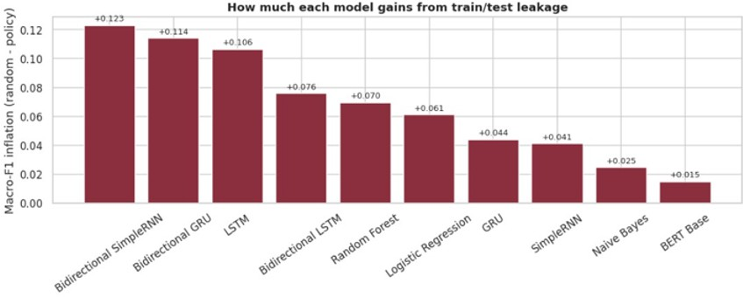

Figure 5: Evaluation-protocol macro-F1 gap (random-split score minus policy-disjoint score) by model; larger bars indicate models whose apparent performance depends more heavily on signal not available under honest evaluation.

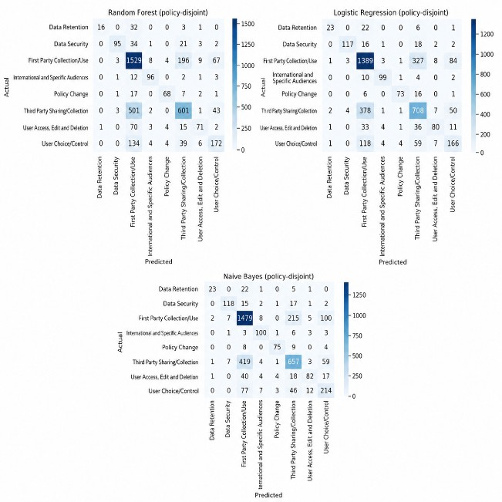
Figure 6: Row-normalised confusion matrix for BERT Base on the policy-disjoint test set. The dominant off-diagonal mass lies between First Party Collection/Use and Third Party Shar-ing/Collection.

yet score highest, because both use distinctive formulaic vocabulary (we may update this pol-icy from time to time; residents of the Euro-pean Economic Area) that a model learns from relatively few examples.
The dominant error mode is confusion be-tween First Party Collection/Use and Third Party Sharing/Collection: both de-scribe data collection and differ chiefly in who receives the data, a distinction sometimes carried by a sin-gle noun phrase within a short span. Despite being the two largest categories, they post the two weakest F1 scores among the frequent classes (0.77 and 0.65). Data Retention is the
one category where scarcity appears to matter: precision is high (0.86) but recall is the lowest of any category (0.35), consistent with a model that recognizes the category when it commits to it but has too few training examples to do so reliably.
Best and worst configurations. Among the 60 tuning runs, the winning configuration for BERT Base under the policy-disjoint scheme is lr = 3×10-5, batch size 32 (validation macro-F1 0.723, test macro-F1 0.706). The win-ning classical configuration is Naive Bayes with α = 0.05 (validation macro- F1 0.680, test macro-F1 0.701). The weakest configu-ration across all models is SimpleRNN with embed=128, hidden=64, dropout=0.3, lr=10-3 under the policy scheme (validation macro-F1 0.110). The full 60-run log is in the project notebook (project_440.ipynb).

  - Representation Status

TF-IDF is the only representation with com-pleted downstream classification; every clas-sical model result in Table 3 uses TF-IDF. The skip-gram Word2Vec pipeline was imple-mented using 100-dimensional embeddings, a context window of 5, and minimum token count of 2. However, the Word2Vec pipeline was not executed for a completed downstream clas-sification experiment, so no Word2Vec classification results are reported. GloVe was not implemented. BERT Base results come from partial, layer-frozen fine-tuning; no full fine-tune was attempted.

- Conclusion

Key findings. Evaluating on a conventional row-level split changes not just the absolute numbers but which model ap-pears to win (RQ1). The evaluation-protocol gap is largest for the recurrent architectures trained from scratch and smallest for BERT Base and the classical models (RQ2). Under hon-est, policy-disjoint evaluation, BERT Base leads at macro-F1 0.706, narrowly ahead of Naive Bayes (0.701); the classi-cal models compet-itiveness suggests that privacy-practice cate-gories carry strong lexical cues that TF-IDF captures ef-fectively on short spans (RQ3). We take the leakage-versus-honest contrast as evidence that document-grouped evaluation should be standard practice for any text classi-fication task built on documents with reused, template-like language contracts, regulatory filings, terms of service, form letters.
Limitations. The six recurrent models pro-cess every padded position in a 48-token se-quence without length mask-ing; short spans continue being processed through trailing padding, which may partly explain the re-current familys large evaluation-protocol gap. The executed pipeline applied base preprocess-ing to the recurrent models rather than the designed lemmatized variant; the isolated ef-fect is untested. Ran-dom seeds are not re-set per configuration inside the recur-rent tun-ing loop. Only TF-IDF downstream classifi-cation is complete; word2vec was not evalu-ated and GloVe was not implemented. BERT results come from partial, layer-frozen fine-tuning rather than a full fine-tune. All results are oracle-span: a deployed system would addi-tionally need an upstream span-detection step. Future work. The most pressing fixes are re-training the six recurrent models with length-aware packing and per-configuration seed re-sets, completing the word2vec down-stream evaluation, and applying the designed lemma-tized pre-processing to the recurrent models to isolate its effect. Beyond that, the 34.9% of clauses that carry multiple categories sug-gest feeding span-plus-clause context should specifically help the First Party versus Third Party confusion, since the distin-guishing noun phrase often sits just outside the annotated span. Minority-class-aware training strategies
should help Data Re-tention the one cate-gory where scarcity is the bottleneck more than the semantically overlapping majority categories. A full, non-frozen BERT fine-tune given GPU access is expected to leave real headroom above the reported figures.

References
Bird, S., Klein, E., & Loper, E. (2009). Natural language processing with Python. OReilly Media. Cho, K., van Merriënboer, B., Gulcehre, C., Bah-danau, D., Bougares, F., Schwenk, H., & Bengio,
Y. (2014). Learn-ing phrase representations us-ing RNN encoderdecoder for statistical machine translation. Proceedings of EMNLP, 17241734.
https://doi.org/10.3115/v1/D14-1179
Devlin, J., Chang, M.-W., Lee, K., & Toutanova,
K. (2019). BERT: Pre-training of deep bidirec-tional transformers for language understanding. Proceedings of NAACL-HLT, 41714186. https:
//doi.org/10.18653/v1/N19-1423 Gorman, K., & Bedrick, S. (2019). We need to talk about standard splits. Proceedings of ACL, 27862791. https://doi.org/10.18653/v1/ P19-1267
Harkous, H., Fawaz, K., Lebret, R., Schaub, F., Shin, K. G., & Aberer, K. (2018). Polisis: Auto-mated analysis and presen-tation of privacy poli-cies using deep learning. Proceedings of USENIX Security, 531548.
Hochreiter, S., & Schmidhuber, J. (1997). Long short-term memory. Neural Computation, 9(8), 17351780. https://doi.org/10.1162/neco.
1997.9.8.1735
Johnson, J. M., & Khoshgoftaar, T. M. (2019). Survey on deep learning with class imbalance. Journal of Big Data, 6(1), Article 27. https:
//doi.org/10.1186/s40537-019-0192-5 Lewis, P., Stenetorp, P., & Riedel, S. (2021). Question and an-swer test-train overlap in open-domain question answering datasets. Proceedings of EACL, 10001008.
McDonald, A. M., & Cranor, L. F. (2008). The cost of reading privacy policies. I/S: A Journal of Law and Policy for the Information Society, 4(3), 543568.
Mikolov, T., Chen, K., Corrado, G., & Dean, J. (2013). Ef-ficient estimation of word representa-tions in vector space. ICLR Workshop.
Paszke, A., Gross, S., Massa, F., Lerer, A., Bradbury, J., Chanan, G., Killeen, T., Lin, Z., Gimelshein, N., Antiga, L., Desmaison, A., Köpf, A., Yang, E., DeVito, Z., Rai-son, M., Tejani, A., Chilamkurthy, S., Steiner, B., Fang, L., Bai, J., & Chintala, S. (2019). PyTorch: An imperative style, high-performance deep learning library. NeurIPS, 32, 80248035.

Pedregosa, F., Varoquaux, G., Gramfort, A., Michel, V., Thirion, B., Grisel, O., Blondel, M., Prettenhofer, P., Weiss, R., Dubourg, V., Vander-plas, J., Passos, A., Cournapeau, D., Brucher, M., Perrot, M., & Duchesnay, É. (2011). Scikit-learn: Machine learning in Python. Journal of Machine Learning Research, 12, 28252830.
Pennington, J., Socher, R., & Manning, C. (2014). GloVe: Global vectors for word representation. Proceedings of EMNLP, 15321543. https:// doi.org/10.3115/v1/D14-1162
R ehurek, R., & Sojka, P. (2010). Software frame-
work for topic modelling with large corpora. Pro-ceedings of the LREC Workshop on New Chal-lenges for NLP Frameworks, 4550.
Schuster, M., & Paliwal, K. K. (1997). Bidirec-tional recurrent neural networks. IEEE Trans-actions on Signal Processing, 45(11), 26732681.
https://doi.org/10.1109/78.650093 Wilson, S., Schaub, F., Dara, A. A., Liu, F., Cherivirala, S., Leon, P. G., Andersen, M. S., Zim-meck, S., Sathyendra, K. M., Russell, N. C., Nor-ton, T. B., Hovy, E., Reidenberg, J., & Sadeh, N. (2016). The creation and analysis of a website pri-vacy policy corpus. Proceedings of ACL, 13301340. https://doi.org/10.18653/v1/P16-1126 Wolf, T., Debut, L., Sanh, V., Chaumond, J.,
Delangue, C., Moi, A., Cistac, P., Rault, T., Louf, R., Funtow-icz, M., Davison, J., Shleifer, S., von Platen, P., Ma, C., Jernite, Y., Plu,
J., Xu, C., Le Scao, T., Gugger, S., Drame,
M., Lhoest, Q., & Rush, A. M. (2020). Trans-formers: State-of-the-art natural language process-ing. Proceedings of EMNLP: System Demon-strations, 3845. https://doi.org/10.18653/ v1/2020.emnlp-demos.6

